Name _________________________________________

Quadratics REVIEW

1. Factor each of the following:
   1. $5x^{3}+x^{2}-20x-4$ b. $15x^{2}-7x-2$

1. Solve $x^{2}+10x-13=0$ by the method of completing the square. Leave the answer in radical form.
2. Solve $5x^{2}+3x-9=0$ using the quadratic formula. Round your answer to the nearest hundredth.
3. Write the equation of each of the parabola given the following information.
   1. vertex at (-5,-3) and a directrix at y = 3 b. focus at (6,2) and directrix at x = -4
4. Graph each of the following parabolas:
   1. $y=\frac{1}{12}{(x-3)}^{2}+2$ b.

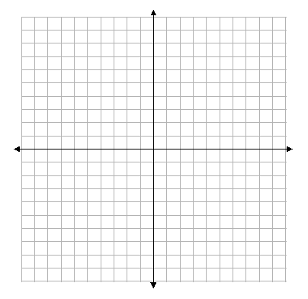

Vertex: Vertex:

Focus: Focus:

Directrix: Directrix:

1. An object is launched at $19.6$ meters per second from a $58.8$ meter tall platform. The equation for the object’s height s at time t seconds after launch is $s\left(t\right)=-4.9t^{2}+19.6t+58.8$, where $s$ is in meter and $t$ is in seconds. What is the objects maximum height? When does the object strike the ground?